Program Structures and Algorithms

Spring 2023(SEC – 03)

NAME: Changyu Wu

NUID: 002111594

**Task: Assignment 3 (Benchmark)**

**Observation:**

In the package “edu.neu.coe.info6205.sort.elementary”, I created an InsertionSortBenchmark class, which tested insertion sort mean lap time with four different input arrays. Results were posted below.

1. The reverse-ordered input array took the longest time to finish sorting. When N became larger, the increment of mean lap time also grew faster than other three inputs. Because it needed to swap every number to put them on the right places, which required more operations.
2. The ordered input array, on the contrary, consumed the least time to finish sorting process. And it took almost the same time when N became larger.
3. The random input array took slightly more time than the partially-ordered array. This probably because random array also had some parts that already been ordered. While the partially-ordered input, in my test case, was set to a 34% ordered array, which might be more organized than the random one.

**Graphical Representation:**

Insertion sort mean lap time (msec) with four different input arrays

Spreadsheet

**Test Screenshots:**

Part 1:

Unit tests in BenchmarkTest

Unit tests in TimerTest

Part 2:

Unit tests in InsertionSortTest

Part 3:

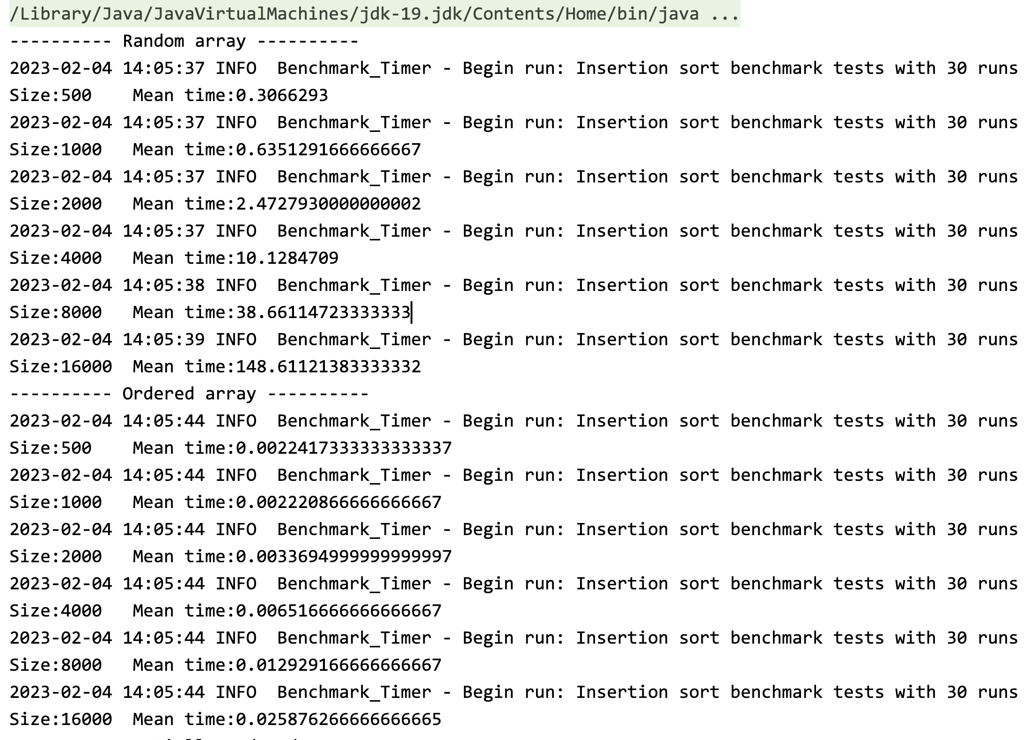

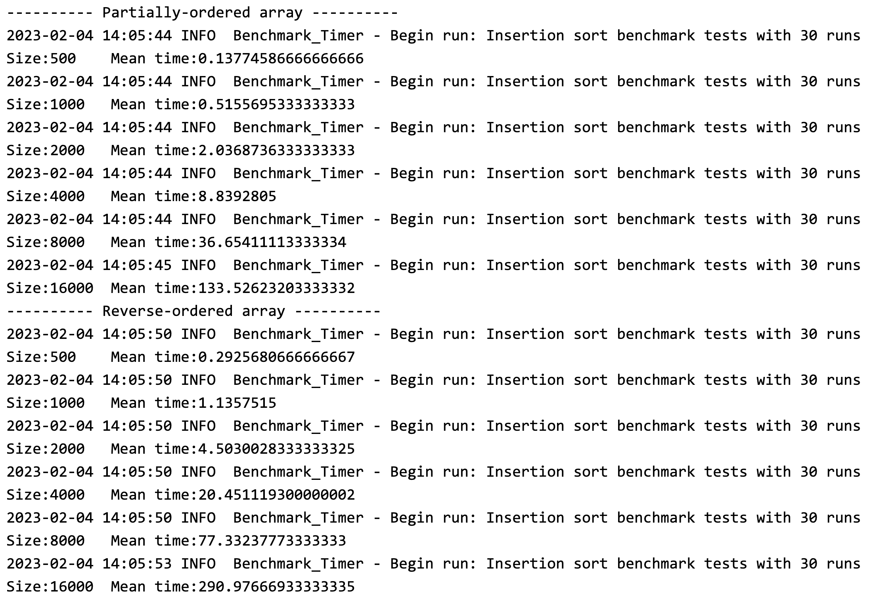

Insertion sort benchmark